# FRONT END FEATURES:

It is the features which the users can interact with in the website. It is the client side of an application. Anything that the user sees and interacts with in a website or an application is the front end part of the website. For example, font, text, images, colours, links

# BACK END FEARURES:

These are features that are hidden from the users and can only be accessed by using specified tools. It is the server side of an application. Hacking takes into considerations the backend features. For example, ip addresses, domain name, programming languages, registrant details, databases

## TARGET: byjus.com

### Front end features



colour

font

image

text

## Backend features:

Ip address from dns lookup

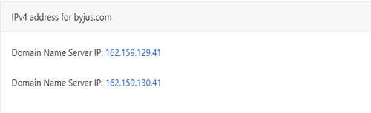

Domain information

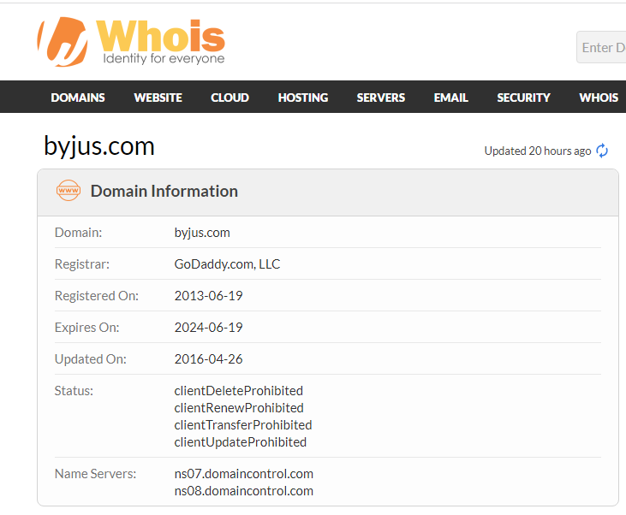

Programming language:

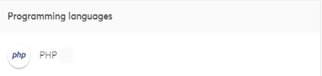

Database:

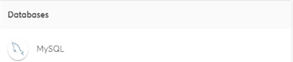

Registrant details:

